# Case Study 2

## MSDS 6306 Doing Data Science: An Introduction to Data Science

*Abou El Dahab, Georges Michel; Shaver, Nicole; Nelson, John; Tuttle, Nathan*

GitHub Link

<https://github.com/JackNelson/DDS-Case_Study2>

Question 1 (15 points)

Create the X matrix and print it from SAS, R, and Python.

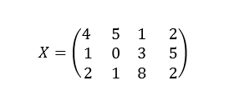

## SAS code (5 points)

proc iml;

X={4 5 1 2,1 0 3 5,2 1 8 2};

print X;

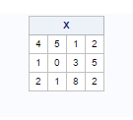

R code (5 points)

casestudy2 = matrix(c(c(4,5,1,2),c(1,0,3,5),c(2,1,8,2)),nrow=3,ncol=4,byrow=TRUE)

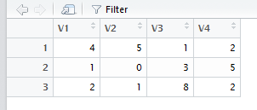

Python Code (5 points)

# This code demonstrates how to create a matrix in Python

import numpy

X =numpy.matrix([[4,5,1,2],[1,0,3,5],[2,1,8,2]])

# Make it python 3 compatible

print(X)

